**Project:** CGFacilities

**General information:**

We have 2 projects configured in the application:

* Front end with Angular named as “POC”

This project is related to the front end of the application where user can work using the User Interface.

* Services as backed named as: “POCAPI”

This project handles the rest based services which are responsible to pass the calls of front end operation to the database

**Guidelines to setup the environment both the projects to host on IIS:**

* Please install Visual Studio 2015 or above version for setting up the project.
* Please download and install nodejs from <https://nodejs.org/en/download/>. Please install the “Recommended for most users” only and not the “Current”.
* Please open the solution of the and right click on the “POCAPI” project and click on “Set as Startup Project” node.
* Please right click on the solution and click properties:

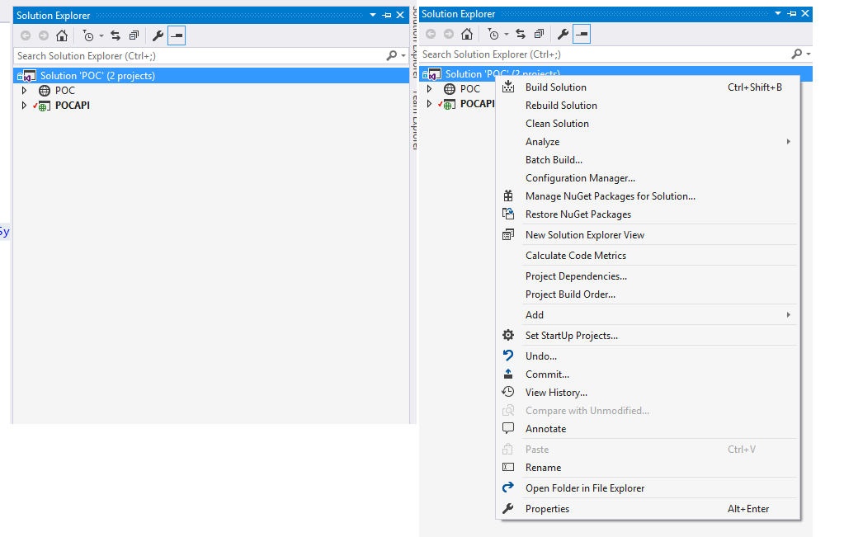

* You will get the “Solution ‘POC’ property pages” dialog box

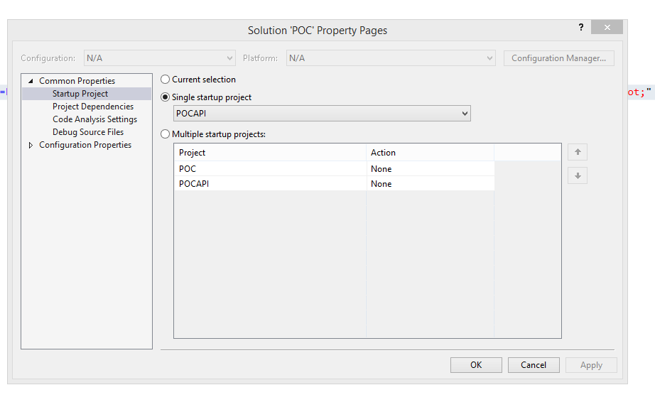

* Please make sure that only POCAPI is configured to run using Visual Studio.

**To run the Services POCAPI project:**

* Please hit f5 or run the project using visual studio
* It will open the browser with services running

**To run the Angular POC project:**

* Please open node command prompt
* Please go to the root directory of the angular project inside folder explorer. Copy the full path of this location.
* Please navigate to this path in node command prompt: cd path-to-your-angular-application

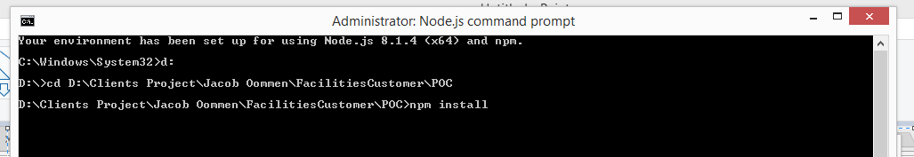

* Please type “npm install” and hit enter: This will install the packages needed for the application to run
* Please type “npm install --save @angular/material @angular/cdk” and hit enter
* Please type “npm install --save @progress/kendo-angular-grid @progress/kendo-angular-dropdowns @progress/kendo-angular-inputs @progress/kendo-angular-dateinputs @progress/kendo-data-query @progress/kendo-angular-intl @progress/kendo-angular-l10n @progress/kendo-drawing @progress/kendo-angular-excel-export @angular/animations” and hit enter
* After successfully executing the above command, please type “ng serve”. This will start running the application. In the example shown below the application is running on : http://localhost:4200/
* 